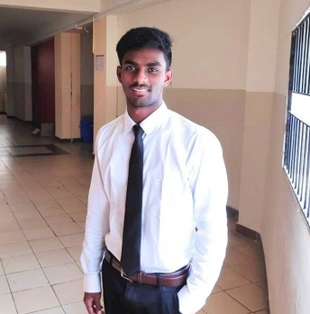

**Gonthini Bhaskar**

 **: +91 8790103186 |  :** [**bhaskarin1india2@gmail.com**](mailto:bhaskarin1india2@gmail.com) **|  :** [**GitHub**](https://github.com/avs-abhishek123) **|  :** [**LinkedIn**](https://www.linkedin.com/in/abhishek-a-v-s-381937156/) **|**

 **:** D.no1-135/c, NTR colony,Parawadapalem village, Anakapalle, Visakhapatanam, AP-531031,INDIA

**Education**

**Bachelors of Technology, VIT University, Vellore, India CGPA: 7.6 / 10.0 2016 - 2020**



▪ Major in **Computer Science & Engineering**, - coursework included Computer Vision, Machine

Learning , python & Data visualization, IOT, Web Development & DBMS. [[Degree Certificate]](https://drive.google.com/file/d/1LcBdDDqZU2ieC5kiBZB-yZ_3PfmbU16H/view?usp=sharing)

[**Jawahar Navodaya Vidyalaya**](https://www.navodaya.gov.in/nvs/nvs-school/VISAKHAPATNAM/en/home/)  (CBSE Stream) **2008 - 2015**

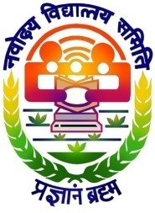▪ Class 12: **77.2 %** [[Mark Sheet] , Class 10 :](https://drive.google.com/file/d/1kUb7CCz-xWwGePxPobaK55zm5yQ7K-5L/view?usp=sharing) **8.8/10.0** [CGPA [Mark Sheet]](https://drive.google.com/file/d/1xXDVz9BKe-bykIbYa8wQiejAhH8tedaM/view?usp=sharing)

▪ Educational Scholorship by Government of india which provides free education and resources for the class 8 to class12.

▪ Selected for a JENESYS program- a 10 day tour to japan as an exchange culture program for students who excelled in both academics and sports. But JNV vizag students missed the tour due to HUDH-HUDH thoofan which makes impossible to reach delhi on time.

**Work Experience**

**NICO Info Systems Inc, Telangana, India** *Data Analytics Intern* **May’19-Jun’19**

▪ Successfully developed a **Credit card fraud Detection application** by using various

Clustering & Machine Learning concepts. [[Certificate]](https://drive.google.com/file/d/1sdqPPkYjVdr-Hycsf_KEI0OD5nkvI1v8/view?usp=sharing)

**Technical Skills**

▪ **Skills –** OOPS ( Python ), Machine Learning, Microsoft Office, Data Structures and algorithms, Report Making, Digital Marekting, SEO, SEM, Email Marketing, Social media Marketing, Freelancer, Canva,

▪ **Tools/Environments–** Google Colab, Jupyter Notebook, Matplotlib, Pyplot, Pandas, Numpy, Pycharm, Canva, OBS Studio

**Projects**

▪ [**Twitter sentimental analysis-**](https://github.com/avs-abhishek123/Twitter-Sentimental-Analysis) Successfully wrote a clean, well-crafted **python** code for **a twitter sentimental analysis** model with **data manipulation**, data storage & visual effects. Learnt to access token, API extraction & storing data in a **CSV file**. [[Source Code]](https://github.com/avs-abhishek123/Twitter-Sentimental-Analysis)

▪ [**Face &Emotion Recognition using Python-**](https://github.com/avs-abhishek123/Emotion-Recognition-using-Neural-Network) Successfully **improved efficiency by 30%** of face detection & Emotion recognition models using python. [[Source Code]](https://github.com/avs-abhishek123/Emotion-Recognition-using-Neural-Network)

▪ [**Hospital Management System-**](https://github.com/avs-abhishek123/Hospital-Management-System)Successfully fortified 1 end to end **relational database** for Hospital Management system. [[Source Code]](https://github.com/avs-abhishek123/Hospital-Management-System)

**Leadership Experience & Achievements**

**Riviera –Cultural Fest** *Marketing & Event Coordinator* **2018-2019**

*  Top **4%** of the student body club and recruited & managed a team of **120** university students volunteering for P&M [Publicity & Marketing].
* Gained **valuable experience** in leadership, excellent problem-solving skills, team-building, teamwork, effective communication, marketing, event workflows & risk management, efficient time management & exhibiting the ability to adapt to changes.

**Gravitas – Technical Fest** *Junior Event Head* **2017-2018**

* 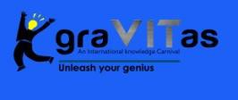Top **35**% of the student body club. **Promoted** through social media about the events of the annual Technical fest - Gravitas, VIT University.
* Recruited &lead a team of **40** university students volunteering for P&M [Publicity & Marketing].

**Program representative for all CSE students 2016-2017**

* A group of 4 people will represent all 1500 CSE students, they attend meetings with professors and try to suggest solutions for the problems facing by students, and conduct workshops and meetings with students.

**Two time National volleyball player**

* Represented Hyderabad region in nation-swide volleyball competition among 600+ schools.

**Additional Information**

**Certifications**

▪ Google Digital Marketing. [[Certificate]](https://drive.google.com/file/d/1noq0vfkD0WEwbJo6OYKS_0iwWF1uJGsV/view?usp=sharing)

▪ Linkedin courses(Digital Marketing, Python).

**Social Work Experience**

▪ **ATK spiritual service society (NGO):** Teacher at NGO, Congregated funds for our annual charity by **25K** INR [2016],

**30K** INR [2017], **25K** INR [2018] & **15K** INR [2019]. [[Certificate]](https://drive.google.com/drive/folders/1U7B-rdgCM490HWnbe0M1IeKox_ETl35m?usp=sharing)

**Hobbies:**

▪ **Video Editing & Content creation -**

o I enjoy editing videos of my pet dog scooby & uploading content on **YouTube**. My YouTube channel is- [[Bhaskar]](https://www.youtube.com/channel/UCXfet7mv1uxFUxT1EWz7BIA)

▪ **Sports & Games -**

o Used to play Volleyball.

o Professional Gamer collaborated and organized live streams along with Kokan Gaming [[YouTube Channel](https://www.youtube.com/c/KOKANGAMINGYT)]

**Other Activities:**

Enjoy listening to music, Watching Sitcoms

**Languages Known:**

Fluent in English, Hindi, Telugu